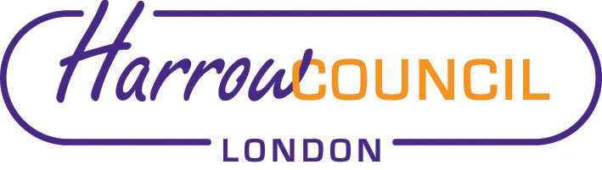
Harrow SACRE Meeting

Thursday 25 June 2020 at 7.30 p.m.
To be held via video conferencing

Enquiries & apologies to:
Vivian Wright, Clerk to SACRE
vmwright@waitrose.com

Adviser to SACRE: Lesley Prior

Agenda
- Welcome:

- Apologies for absence:

- Minutes of the last meeting on 10 December 2019: to agree the minutes as a true record.

- Matters arising from the minutes

- What are Ofsted Inspectors saying about Religious Education?

- News from NASACRE

- Determinations

- Marlborough Determination

- Collective Worship working group

- Days of Religious observance: review text

- News from Faith Groups relating to schools

- Any Other Business
- SACRE address list - update

- Future Dates

- Thursday 25 June
- Tuesday 29 September
- Thursday 10 December
- Tuesday 9 March 2021

